IDEATION PHASE – CUSTOMER JOURNEY MAP
Date: 31 January 2025
Team ID: SWTID-2026-2896
Project Name: Script-Controlled ACL – Restrict Record Access Based on Field Value
Scenario: A ServiceNow user accesses Institution Details records, while the system checks their role and permissions.
1. ENTICE – Initial Awareness
Steps: Log in to ServiceNow
Experience: The user logs in to the ServiceNow platform to access institution records.
Interactions:
- ServiceNow login page
- Username and password
- User dashboard
Things / Places / People: Computer, web browser, ServiceNow platform, administrator.
Goals & Motivations:
- Help me log in securely.
- Help me access the records I am authorized to view.
Positive Moments: The user can access the ServiceNow dashboard successfully.
Negative Moments: Login problems or missing roles may prevent access.
Areas of Opportunity: Make login and role assignment clear and secure.
2. ENTER – Open Institution Details
Steps: Navigate to the Institution Details table.
Experience: The user opens the custom u_institution_details table to view student information.
Interactions:
- ServiceNow application navigator
- Institution Details list
- Student records
Things / Places / People: Computer, browser, ServiceNow administrator.
Goals & Motivations:
- Help me find the required institution records quickly.
Positive Moments: The user can locate the required table easily.
Negative Moments: The user may not know why certain records are restricted.
Areas of Opportunity: Provide clear access-denied messages and understandable navigation.
3. ENGAGE – View Records
Steps: Read institution records.
Experience: The READ ACL checks the user's role and configured record conditions before allowing access.
Interactions:
- READ Access Control List (ACL)
- User roles such as bb1
- Branch field, such as EEE
- Institution Details records
Things / Places / People: ServiceNow ACL configuration, user account, administrator.
Goals & Motivations:
- Help me view only records I am authorized to access.
- Help me protect student information from unauthorized users.
Positive Moments: Authorized users can view permitted records.
Negative Moments: Incorrect ACL conditions may allow unwanted access or block legitimate users.
Areas of Opportunity: Configure the Branch condition correctly and test access using different roles.
4. ENGAGE – Create and Modify Records
Steps: Create or update institution records.
Experience: The user attempts to create a new record or update an existing record. The corresponding ACL checks the required role.
Interactions:
- CREATE ACL requiring bb2
- WRITE ACL requiring bb3
- Institution Details form
- Record update operations
Things / Places / People: ServiceNow forms, ACL rules, administrator.
Goals & Motivations:
- Help me create records when I have permission.
- Help me update information without unauthorized changes.
Positive Moments: Users with the required permissions can perform their assigned tasks.
Negative Moments: Missing permissions or incorrect ACL settings can prevent valid operations or permit unwanted changes.
Areas of Opportunity: Test CREATE and WRITE permissions separately for each user role.
5. EXIT – Delete Records and Finish
Steps: Delete a record or finish the task.
Experience: The user attempts to delete a record. The DELETE ACL checks whether the user has the required role.
Interactions:
- DELETE ACL requiring bb4
- Delete action
- Access-control validation
Things / Places / People: ServiceNow table, ACL rules, administrator.
Goals & Motivations:
- Help me delete records only when authorized.
- Help me prevent accidental or unauthorized deletion.
Positive Moments: Only appropriately authorized users can perform permitted delete operations.
Negative Moments: Incorrect DELETE ACL configuration may expose records to unauthorized deletion or block legitimate tasks.
Areas of Opportunity: Test deletion permissions and verify that administrators retain the intended access.
6. EXTEND – Testing and Improvement
Steps: Validate permissions and improve security.
Experience: The administrator tests the ACL rules with users who have different roles and verifies the results.
Interactions:
- User impersonation and access testing
- ACL configuration
- Role assignments
- Test records from different branches
Things / Places / People: ServiceNow platform, administrator, test users.
Goals & Motivations:
- Help me confirm that the access rules work correctly.
- Help me maintain student data privacy and system security.
Positive Moments: Correctly configured ACLs provide controlled access to records.
Negative Moments: Untested ACLs may cause security gaps or unexpected access-denied errors.
Areas of Opportunity: Perform regular testing of READ, CREATE, WRITE, and DELETE ACLs.
Overall Customer Journey Insight
The customer journey begins with logging in to ServiceNow and ends with testing secure access to institution records. Script-controlled ACLs and correctly configured role and Branch conditions help protect student information while allowing authorized users to perform their tasks.

1. Data Flow Diagram (DFD)
External Entity: ServiceNow User
Admin / EEE User / Other Role-Based User
Process 1: Login and Request Record Access
User requests to view, create, update, or delete institution records
Process 2: Script-Controlled ACL Validation
Check user role, ACL permission, and configured Branch condition
Authorized
Allow permitted operation
Unauthorized
Deny access
Data Store: Institution Details Table
institution_details — roll number, student name, faculty, branch, email, phone, description
DFD explanation: The user requests an operation on the Institution Details table. ServiceNow evaluates the applicable ACL and its role/script/field conditions. The operation is allowed only when the required permissions are satisfied; otherwise, access is denied.
2. User Stories
The following table follows the columns in your template.
Data Flow Diagrams and User Stories.docx.pdf
User Type | Functional Requirement (Epic) | User Story Number | User Story / Task | Acceptance Criteria | Priority | Release
EEE User | Read Access | USN-1 | As an EEE user, I want to view authorized EEE institution records. | User with bb1 can read records allowed by the configured Branch condition. | High | Sprint-1
Authorized User | Create Records | USN-2 | As an authorized user, I want to create institution records. | User with bb2 can create records; users without the required permission are denied. | High | Sprint-1
Authorized User | Update Records | USN-3 | As an authorized user, I want to update institution records. | User with bb3 can update records when the applicable ACL permits the operation. | High | Sprint-1
Authorized User | Delete Records | USN-4 | As an authorized user, I want to delete institution records. | User with bb4 can delete records when the applicable ACL permits the operation. | High | Sprint-1
Administrator | Full Access | USN-5 | As an administrator, I want to manage and access institution records. | An administrator can perform permitted administrative operations, subject to the configured ACL behavior. | High | Sprint-1
ServiceNow Administrator | Role Management | USN-6 | As an administrator, I want to assign appropriate roles to users. | Roles bb1, bb2, bb3, and bb4 are assigned and verified correctly. | High | Sprint-1
ServiceNow Administrator | Security Testing | USN-7 | As an administrator, I want to test access restrictions for different users. | Tests confirm that unauthorized read, create, update, and delete operations are denied. | High | Sprint-2
ServiceNow Administrator | Branch-Based Security | USN-8 | As an administrator, I want to restrict record visibility based on Branch. | EEE-only access is enforced through a correctly configured ACL condition or script check. | High | Sprint-2
3. Expected Outcome
- Secure access to the u_institution_details table.
- Role-based control for READ, CREATE, WRITE, and DELETE operations.
- Branch-based record restriction for EEE users.
- Full administrative access as configured.
- Reduced risk of unauthorized viewing, modification, or deletion of student records.

Date: 31 January 2025
Team ID: (Enter your Team ID)
Project Name: Script-Controlled ACL – Restrict Record Access Based on Field Value
1. Functional Requirements
FR No. | Functional Requirement (Epic) | Sub Requirement (Story / Sub-Task)
FR-1 | User Login | Users must be able to log in to the ServiceNow platform.
FR-2 | Role-Based Access Control | Assign roles bb1, bb2, bb3, and bb4 to control record access.
FR-3 | Script-Controlled ACL | Configure READ, CREATE, WRITE, and DELETE ACLs to authorize operations based on roles.
FR-4 | Branch-Based Record Restriction | Restrict EEE users to EEE records using a configured Branch condition or script check.
FR-5 | Record Management | Allow authorized users to view, create, update, and delete Institution Details records.
FR-6 | Administrator Access | Allow administrators the access specified by the configured ACL rules.
FR-7 | Access Validation | Test authorized and unauthorized users to verify that ACL restrictions work correctly.
2. Non-functional Requirements
NFR No. | Non-Functional Requirement | Description
NFR-1 | Usability | The ServiceNow interface should allow users to access permitted institution records easily.
NFR-2 | Security | Protect student information by restricting unauthorized record access and modification.
NFR-3 | Reliability | ACL rules should consistently enforce the configured access permissions.
NFR-4 | Performance | Access checks should complete efficiently without unnecessary delays.
NFR-5 | Availability | The access-control functionality should work whenever the ServiceNow instance is available.
NFR-6 | Scalability | The ACL design should support additional users, roles, branches, and institution records as requirements grow.

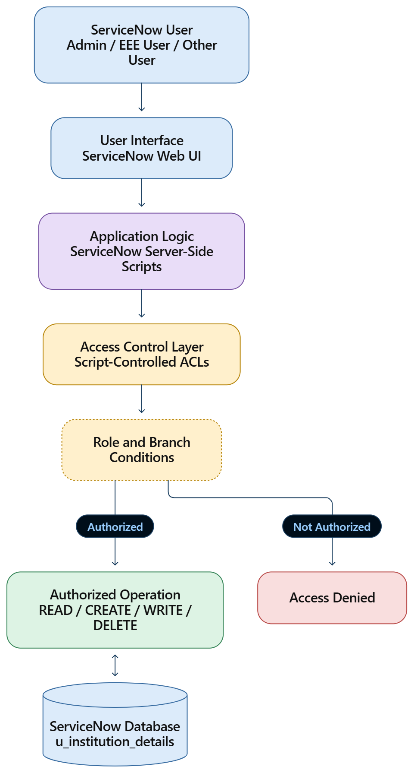
Architecture explanation: The user accesses the ServiceNow web interface. Server-side application logic invokes the applicable Access Control Lists (ACLs). The ACL rules evaluate the required role and configured conditions before allowing an operation on the Institution Details table.
2. Table 1 – Components & Technologies
S.No. | Component | Description | Technology
1 | User Interface | Interface used by users to access institution records. | ServiceNow Web UI, HTML, CSS, JavaScript
2 | Application Logic – 1 | Checks user permissions for reading records. | Server-side JavaScript, READ ACL
3 | Application Logic – 2 | Controls record creation and updates. | CREATE ACL, WRITE ACL
4 | Application Logic – 3 | Controls record deletion and administrator access. | DELETE ACL, role checks, ACL scripts
5 | Database | Stores institution and student-related records. | ServiceNow platform database
6 | Cloud Database | Separately configured cloud database service. | Not separately required; uses the ServiceNow platform database
7 | File Storage | Stores uploaded files, if required. | ServiceNow attachment storage; optional
8 | External API – 1 | External integration for additional data. | Not required for this project
9 | External API – 2 | External service integration. | Not required for this project
10 | Machine Learning Model | AI-based analysis or prediction. | Not required for this project
11 | Infrastructure (Server / Cloud) | Hosts the application, scripts, and database. | ServiceNow instance and its managed infrastructure
3. Table 2 – Application Characteristics
S.No. | Characteristics | Description | Technology
1 | Open-Source Frameworks | Uses the ServiceNow platform's built-in development and scripting capabilities. | Server-side JavaScript, ServiceNow APIs
2 | Security Implementations | Restricts access according to user roles and configured ACL conditions. | Script-Controlled ACLs, roles bb1–bb4, Branch condition, admin role
3 | Scalable Architecture | The application uses the existing ServiceNow platform and can support additional records and roles as requirements grow. | ServiceNow platform architecture
4 | Availability | Application availability depends on the ServiceNow instance and its service availability. | ServiceNow-hosted infrastructure
5 | Performance | ACL scripts should use efficient checks to avoid unnecessary delays when accessing records. | Optimized server-side JavaScript and ACL conditions
4. Technology Stack Summary
Layer | Technology Used
Frontend | ServiceNow Web UI
Backend | Server-side JavaScript
Security | Script-Controlled Access Control Lists
Authentication and authorization | ServiceNow user accounts and roles
Data storage | ServiceNow platform database
Custom table | u_institution_details
Development environment | ServiceNow Studio / plat form development tools

